**Hw4**

(1) result screenshot

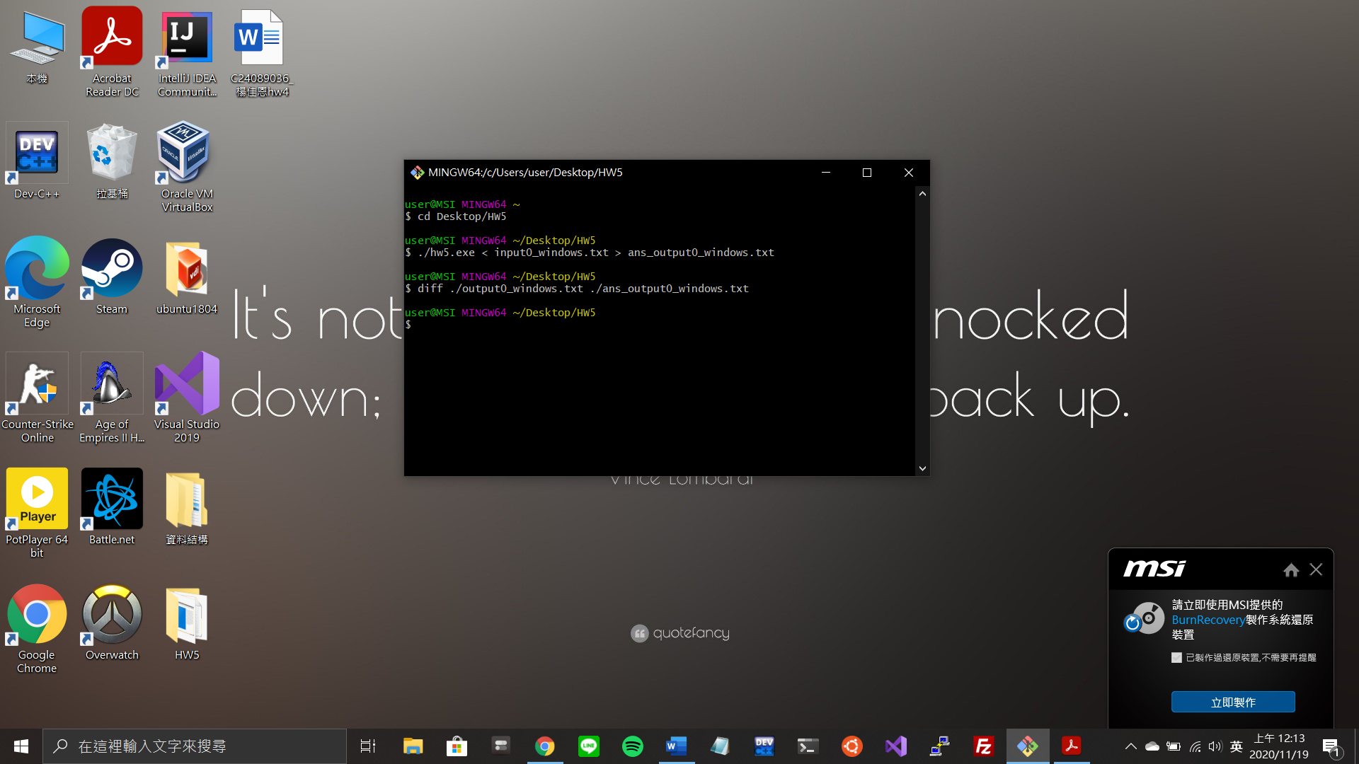

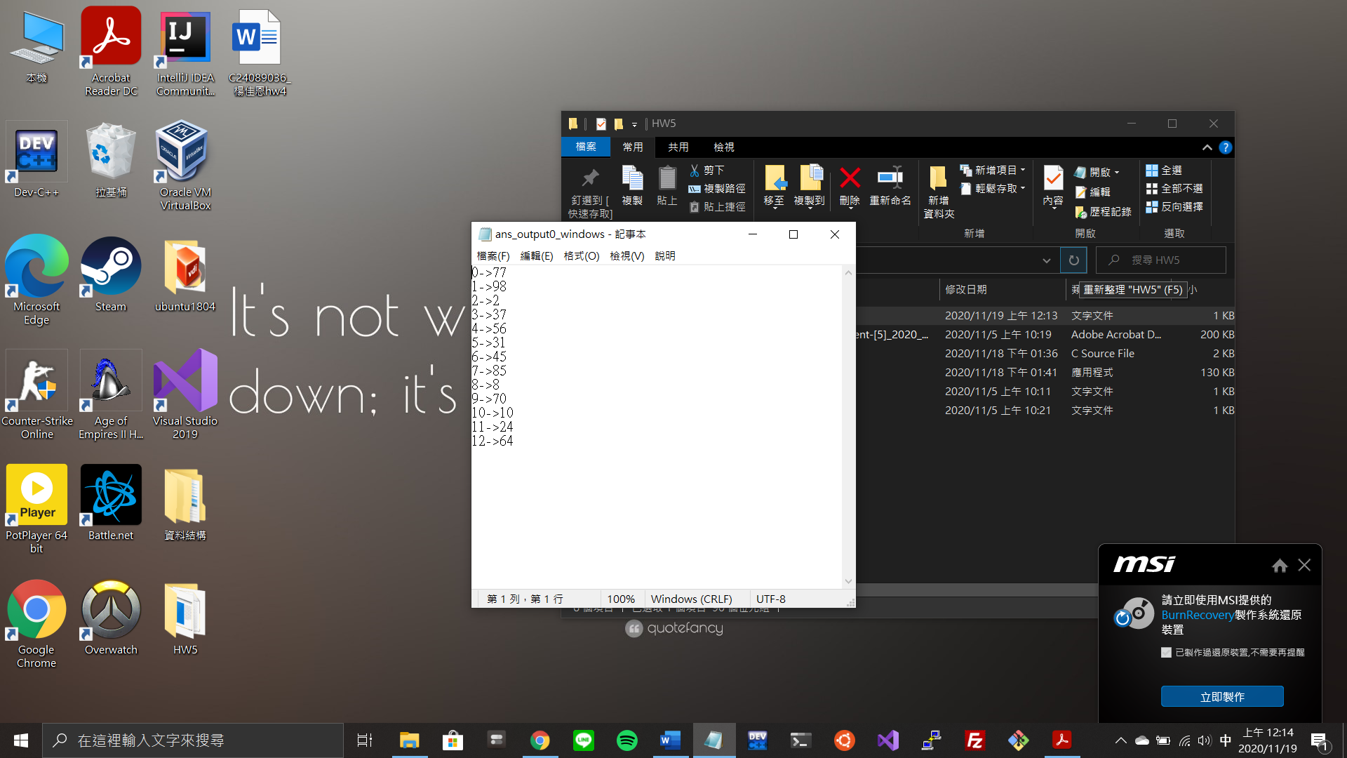

(2) program structure

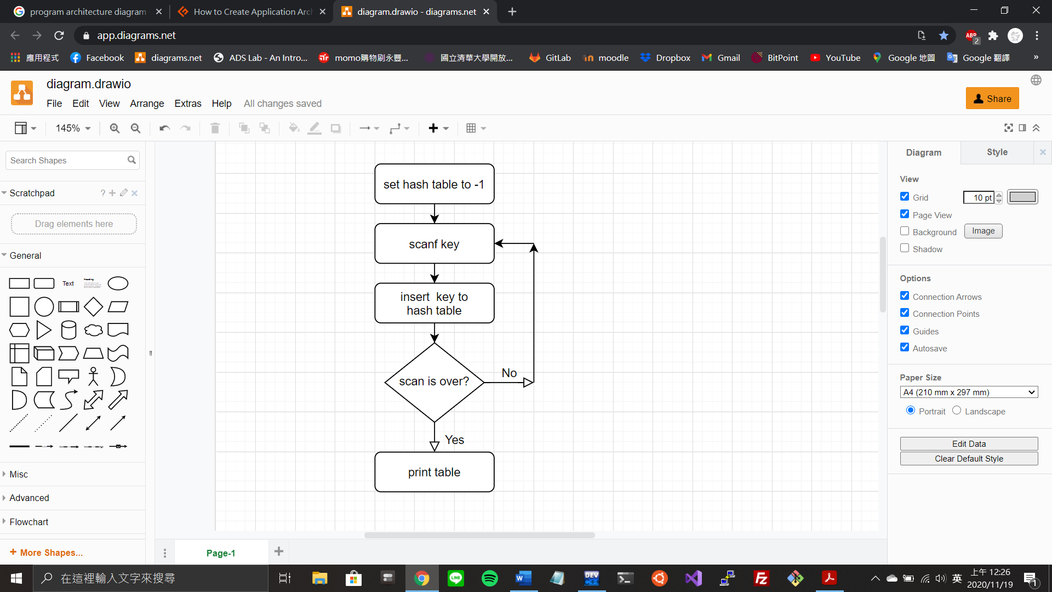

(3) program functions

void insert(int hash_table[TABLE_SIZE], int key)

Features

insert key into hash table

Parameter

hash_table – key將要存入的hash表

key – 將插入的值

Return Value

None

void print_table(int hash_table[TABLE_SIZE])

Features

印出hash table

Parameter

hash_table – 需要印的hash表

Return Value

None